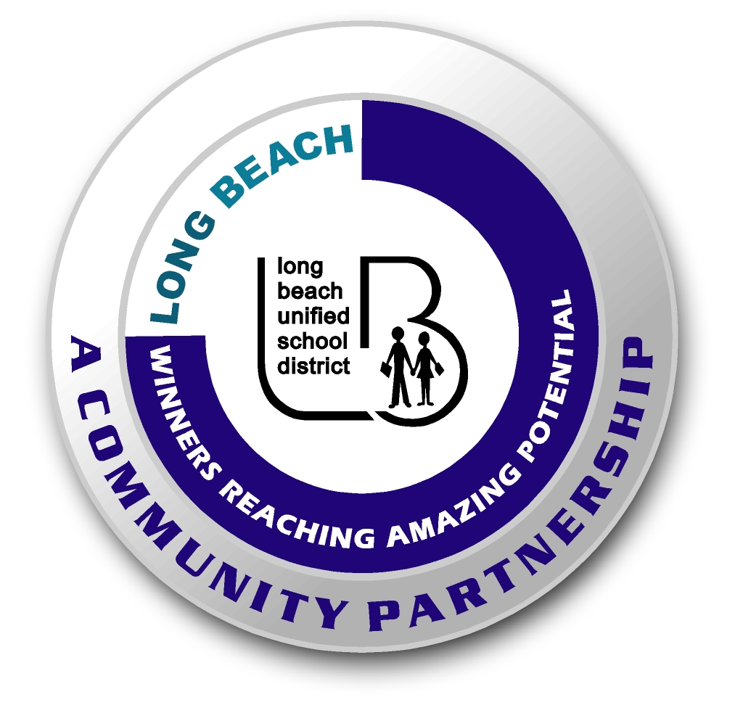
Long Beach WRAP

Lesson Title or Topic: Shiny Pennies

Program Leader: _____________________________ Date: __________

Grade Level: 1st School Site: __________________________

Materials Needed: (List)
- Dull pennies
- Water
- White Vinegar
- Salt
- Glass jar
- Measuring spoons
- Paper towel
- Class graph for predicting

Preparation Time: 10 min Lesson time: 30 min

Content Standard(s):
Physical Science: Materials come in different forms (states), including solids, liquids, and gases. As a basis for understanding this concept: Students know the properties of substances can change when the substances are mixed, cooled, or heated. Students know solids, liquids, and gases have different properties.

Investigation and Experimentation: Students will draw pictures that portray some features of the experiment, record observations and data with pictures, numbers, or written statements, and record observations on a bar graph.

What will be learned from this activity? (Objective)
Students will learn that the two substances can combine to form a new substance.

Steps of the lesson: (Scientific Method of Investigation)
Information: The dull film on the pennies forms when oxygen atoms from the air join the copper atoms in the pennies. Vinegar is acetic acid and table salt is sodium chloride. When the two are mixed together they form hydrochloric acid. The dull film on the pennies breaks down when the oxygen atoms in it join the atoms in the acid mixture leaving the pennies shining like new.

Introduction: (Questions/Hypothesis):
What will happen to dull pennies when they are washed in a mixture of vinegar and salt?

Instruction:
1. Show students materials to be used in the experiment and state the problem.
2. Explain vocabulary for the different hypotheses if necessary.
3. Have students choose a hypothesis. Have students complete this sentence frame: The pennies will _______________________. Possible hypotheses: make a sizzling sound, not change, begin to bounce up and down, or become shiny.
4. Chart all student predictions on a class graph.
5. Ask volunteers to explain the reasons for their predictions.
6. Conduct the experiment.

Activity:
- Put some salt on one penny.
- Record what happens.
- Put some vinegar on another penny.
- Record what happens.
- Mix 6 tablespoons of vinegar and 2 tablespoons of salt in a jar.
- Put the dull pennies in the jar and stir them around for a few minutes.
- Rinse the pennies in water and dry them with a towel.
- Observe what happened.

Closure: (Conclusions/Results)
- What were the results? Discuss the results.
- Have students write: The mixture of salt and vinegar ____________________. Then they can draw a picture of the experiment.

