
Long Beach WRAP

Lesson Title or Topic: Ecology and Me (Building an Ecocolumn)

Program Leader: _____________________________ Date: __________

Grade Level: 6-8th School Site: __________________________

Materials Needed: (List)
- Four 2-liter bottles with caps, Bottle Biology Tool Kit (see handout)
- Soil (dirt), water, plants, compost, local predators (spiders, snails, etc)

Preparation Time: 20 min Lesson time: Day 2 (2 of 3 lessons)

Content Standard(s) Ecology

What will be learned from this activity? (Objective)
- Students will understand the concept of ecosystems.
- Students will understand the importance and role of an ecosystem friendly environment.
- Students will understand how an ecosystem is developed.

Steps of the lesson: (Scientific Method of Investigation)

Introduction: (Questions/Hypothesis):
Think about all the non-human life with which you share your world.
- What sorts of insects inhabit where you live?
- What kinds of plants grow near your school or in cracks in the sidewalk?

Instruction/Activity: (Procedure)
Building Ecocolumn:
- Remove labels from the 2 liter bottles.
- Cut top off Bottle #1 about ½ inch below the shoulder
  - For assembling purposes label this section “A”
- Cut the bottom off ½ inch below the hip
  - For assembling purposes label this section “B”
- Cut top off Bottle #2 about ½ inch below the shoulder
  - For assembling purposes label this section “C”
- Cut the bottom off ½ inch below the hip
  - For assembling purposes label this section “D”
- Cut top of Bottle #3 in half
  - For assembling purposes label this section “E”
  - For assembling purposes label bottom portion of Bottle #3 section “F”
- Cut top off Bottle #4 about ½ inch below shoulder
  - For assembling purposes label this section “G”
  - Discard the remaining portion
- Slide A down into B (top facing up)
  - Tape A/B joint from underneath
  - Apply silicone seal
  - Stack A/B/ in C
- Slide D down into G (top facing down)
  - make sure to punch holes in caps for water sprinkling effect
- Slide D/G into units A/B/C
- Slide E into F (top facing down)
  - make sure to punch holes in caps for water sprinkling effect
- Finally slide the remaining assembled units into E/F.
  - Tape all units that need to be taped.
Closure:
- Review day 2 activities with students.
- See attachments

Bottle Biology Handout Attachment

Tool Box
These tools will enable you to construct any of the investigation columns on this site. Some of these items are not critical – you do not need to use a razor to start bottle cuts, for example, or a tapered reamer to enlarge holes – but they can make construction easier.
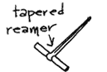 | 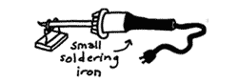 | 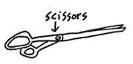
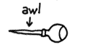 | 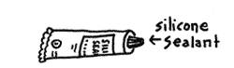 | 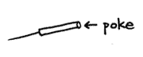
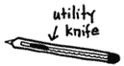 | 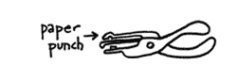 | 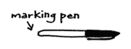
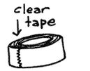 | 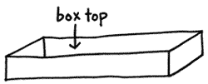 | 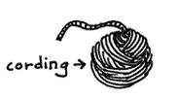
- Box top or drawer to stabilize bottle while making cutting lines
- Marker, wax pencil or crayon for drawing cutting lines
- Cutting blade or utility knife to start cut
- Scissors to cut bottle
- "Poke," darning needle or diaper pin to make air holes
- Awl to make holes in bottle caps and film cans
- Tapered reamer for enlarging holes
- Paper punch for making large holes in thin plastic
- Clear waterproof postal or bookbinding tape to join columns
- Silicone sealant to waterproof joints
- Clothes line, polyester or nylon craft cording
- Small inexpensive electric soldering iron
- Hair dryer

