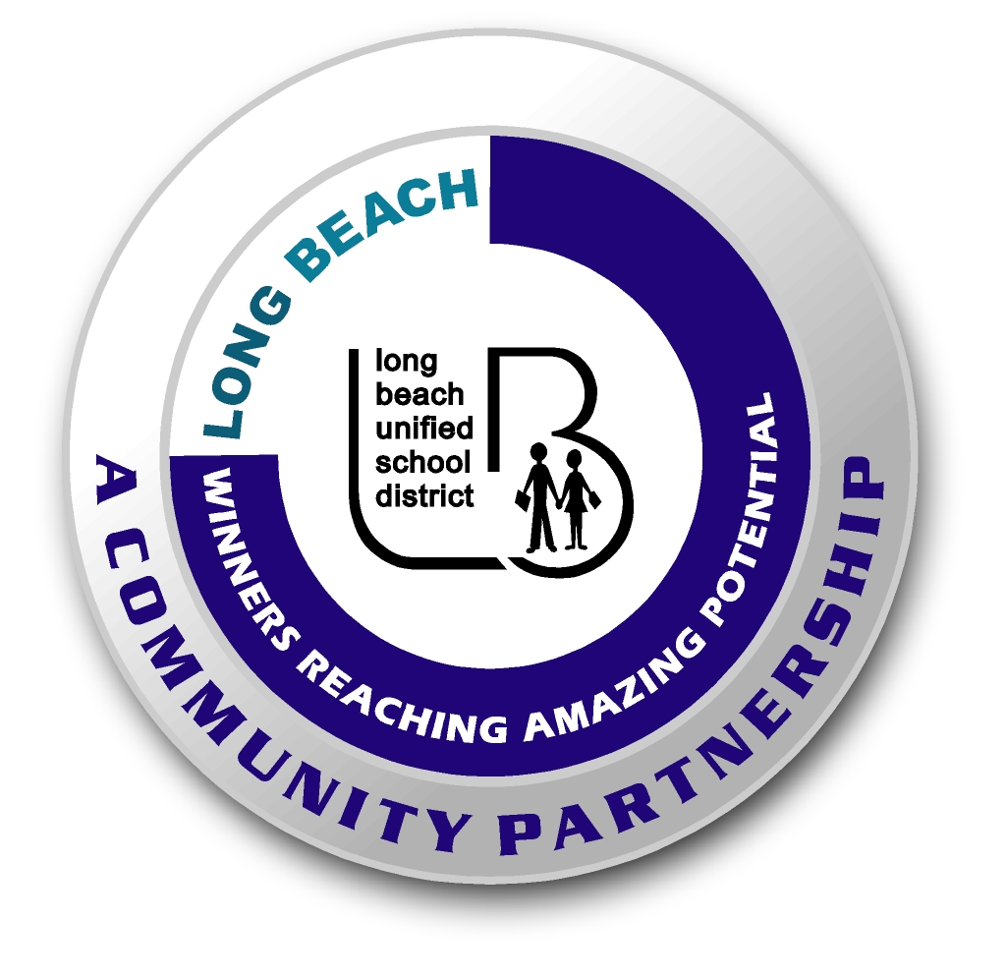
Long Beach WRAP

Lesson Title or Topic: Gotcha (Mini-Experiments)

Program Leader: _____________________________ Date: __________

Grade Level: 6-8th School Site: __________________________

Materials Needed: (List)
- Broomstick (broom), willing students, and apples for each student

Preparation Time: 10 min Lesson time: 20 min

Content Standard(s) Forces

What will be learned from this activity? (Objective)
Students will understand how the center of gravity functions in balancing objects.

Steps of the lesson: (Scientific Method of Investigation)

Introduction: (Questions/Hypothesis):
- Have you ever sat on a teeter-totter with a larger friend?
- How do you balance the teeter-totter to make it level?

Instruction:
- Review safety rules and procedures.
- Review the responsibility associated with experiments.

Activity: (Procedure)
- Have students line up in a straight line. One by one pass out the apples to the students (remind them that they have to wait until to the experiment is over in order to eat the apples).
- Have students crook their elbows around it.
- Put an apple on the floor in front of them.
- Lean forward, using your hands for balance to pick up the apple with their teeth.

Closure: (Conclusions/Results)
- What is the secret?
  - Your center of gravity right over your feet.
- What happens when you lean forward and shift your center of gravity?

