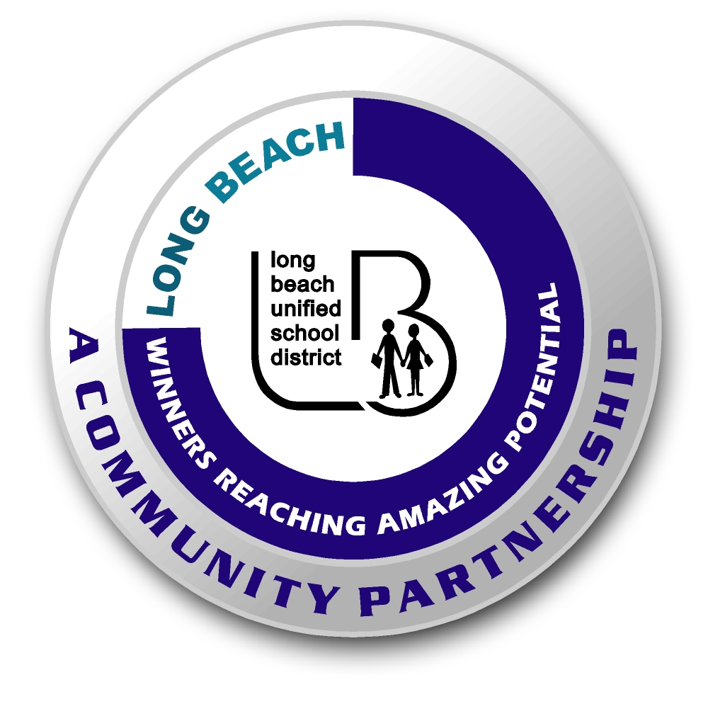
Long Beach WRAP

Lesson Title or Topic: Potential and Kinetic Energy

Program Leader: _____________________________ Date: __________

Grade Level: 6-8th School Site: __________________________

Materials Needed: (List)
- 12 Feet of clear ¼”vinyl tubing
- 3-4 bb’s or other metal balls the same size
- Yard stick

Preparation Time: 10 min Lesson time: 30 min

Content Standard(s) Motion and Forces

What will be learned from this activity? (Objective)
- Students will be able to define Kinetic and Potential energy.
- Students will be able to see the relationship between potential energy and kinetic energy as it relates to height.

Steps of the lesson: (Scientific Method of Investigation)

Introduction: (Questions/Hypothesis):
- Research kinetic and potential energy either from class textbooks or the internet.

Instruction:
- Ask the students to relate their research to building a roller coaster. Think about a roller coaster they have been on and how it is designed before they start.

Activity: (Procedure)
- Divide the class into groups of 3 to 5 students.
- Assign the materials listed above. The groups will try to design a roller coaster with the first hill at a height of 4 feet and two more hills following. The group that is able to design a roller coaster with the most total inches in the height of the three hills wins the class contest.

Closure: (Conclusions/Results)

- Record your results as you try different designs.
- Which design worked the best and why do you think so?

