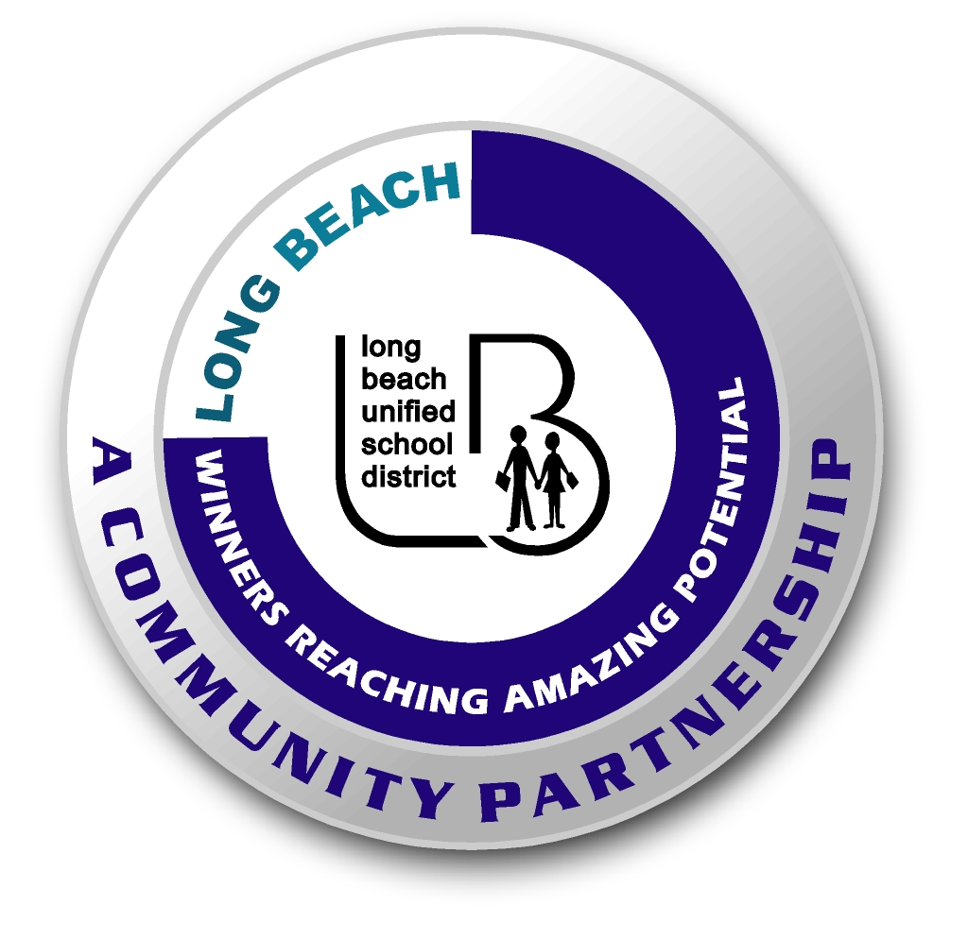
Long Beach WRAP

Lesson Title or Topic: Soapy Boats

Program Leader: _____________________________ Date: __________

Grade Level: 1st School Site: __________________________

Materials Needed: (List)
- Paper boats
- Liquid detergent
- Plastic knife or toothpick
- Water
- Plate
- Class graph for predicting

Preparation Time: 10 min Lesson time: 30 min

Content Standard(s):
Physical Science: Materials come in different forms (states), including solids, liquids, and gases. As a basis for understanding this concept: Students know the properties of substances can change when the substances are mixed, cooled, or heated.

Investigation and Experimentation: Students will draw pictures that portray some features of the experiment, record observations and data with pictures, numbers, or written statements, and record observations on a bar graph.

What will be learned from this activity? (Objective)
Students will learn that soapy water has less surface tension than plain water.

Steps of the lesson: (Scientific Method of Investigation)
Information: Soap will break the surface tension of water. For this reason, paper boats will travel forward when liquid detergent is dropped on the stern. As the surface splits behind the boat, the boat is carried forward on the retreating water “skin”.

Introduction: (Questions/Hypothesis):
What will happen to a paper boat floating on a plate of water when liquid detergent is dropped onto its stern?

Instruction:
1. Show students materials to be used in the experiment and state the problem.
2. Have students choose a hypothesis. Possible hypotheses for what will happen to the cutout put in the soapy water: a. sink, b. flip over, c. travel forward, d. travel backward. These should be the headings on the graph.
3. Chart all student predictions on a class graph.
4. Ask volunteers to explain the reasons for their predictions.
5. Conduct the experiment.

Activity: (Procedure)
- Launch your boat on a plate of water.
- Place a little detergent on a knife and drop it carefully in the stern.
- Observe what happens.

Closure: (Conclusions/Results)
- What were the results?
- Have students write: The boat ___________________. Then they can draw a picture of the experiment.

