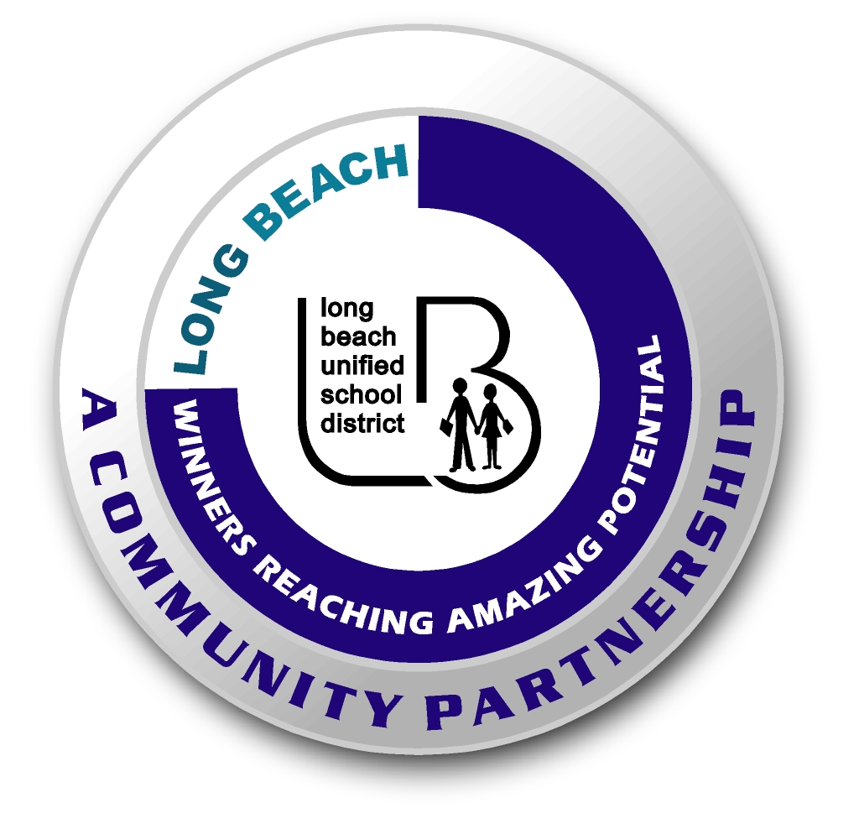
Long Beach WRAP

Lesson Title or Topic: Boiling Ice

Program Leader: _____________________________ Date: __________

Grade Level: 1st School Site: __________________________

Materials Needed: (List)
- Ice Cubes
- Water
- Hot pad or towel
- Microwave oven or hot plate to boil water
- Junior size baby food jar with tight-fitting lid
- Class graph for predicting

Preparation Time: 10 min Lesson time: 30 min

Content Standard(s):
Physical Science: Materials come in different forms (states), including solids, liquids, and gases. As a basis for understanding this concept: Students know the properties of substances can change when the substances are mixed, cooled, or heated. Students know solids, liquids, and gases have different properties.

Investigation and Experimentation: Students will draw pictures that portray some features of the experiment, record observations and data with pictures, numbers, or written statements, and record observations on a bar graph.

What will be learned from this activity? (Objective)
Students will learn that air pressure affects the boiling point of water.

Steps of the lesson: (Scientific Method of Investigation)
Information: Hot air rises. When boiling water in an open heat-proof glass jar, most of the air above the water heats up and leaves the jar. When the lid is placed on the jar, there is a little air and some water vapor left inside. Ice cubes on top of the lid cause the air below the lid to cool and make the water vapor condense. Because of the lower air pressure, the boiling point of the water is decreased, and it will begin to boil again.

Introduction: (Questions/Hypothesis):
What will happen to water in a jar that has stopped boiling when an ice cube is placed on the lid?

Instruction:
1. Show students materials to be used in the experiment and state the problem.
2. Have students choose a hypothesis. Have students complete this sentence frame: The water in the jar will _______________________. Possible hypotheses: freeze, crack the jar, evaporate, or begin to boil.
3. Chart all student predictions on a class graph.
4. Ask volunteers to explain the reasons for their predictions.
5. Conduct the experiment.

Activity: (Procedure) This experiment should be demonstrated by the program leader as it involves using boiling water.
- Fill a heat-proof jar ½ full of water.
- Bring the water to a boil.
- Let the water boil for 1 minute.
- Remove the jar carefully from the heat and place a lid on tightly.
- When the water stops boiling, place an ice cube on top of the lid.
- Observe what happens.

Closure: (Conclusions/Results)
- What were the results? Discuss the results.
- Have students write: The water in the jar ____________________. Then they can draw a picture of the experiment.

